

Cecil Andrews College

Year 11
ATAR
Human Biological Science

Test 3

Digestive and Excretory Systems

Total Marks = 95

Section A. Multiple Choice (25 Marks)
Circle the most appropriate response

Section B. Short Answer (60 Marks)
Place responses in the spaces provided

Section C. Extended Answer (10 Marks)
Place responses in the spaces provided

Name: _____________________________________

Section A – Multiple Choice (Total 20 Marks)

Select the best answer from the alternatives. Circle your answer on this paper.

- The main function of the bladder is to:

  - absorb vitamins.
  - reabsorb water from urine.
  - reabsorb mineral ions from urine.
  - store urine before it is voided.

- Which group represents excretory products found in humans?

  - Glucose, urea, bile salts, amino acids.
  - Water, plasma, urea, carbon dioxide.
  - Carbon dioxide, urea, salts, water.
  - Carbon dioxide, undigested food, salts, water.

- The lungs and intestines have similar structures related to all of the following except:

  - A large surface area enabling rapid diffusion of molecules into the blood.
  - A thin surface lining separating the internal and external environments.
  - A rich supply of blood.
  - A large number of air spaces between the cells to reduce the weight of the organ.

- Which of the following is the best definition of excretion?

  - Excreta is eliminated from the digestive tract.
  - Metabolic wastes from cells are removed from the body.
  - Urea is produced in the liver.
  - Deamination occurs in the liver.

- In a normal healthy person, glucose is not normally found in the urine because:

  - glucose is too large a molecule to be filtered by the kidneys.
  - glucose is used in respiration to produce energy for movement.
  - glucose is reabsorbed after the filtration process and passed back into the blood.
  - excess glucose is converted to glycogen and stored in liver and muscles.

- After digestion and absorption into the villi of the small intestine, which of the following nutrients would enter the blood stream via the lymphatic system at the thoracic duct?

  - Sugar.
  - Amino acids.
  - Lipids.
  - Vitamins.

- Haemodialysis is a treatment used by someone who has kidney failure. It involves:

  - surgical replacement of a diseased kidney.
  - passing blood through a dialysis machine where filtration occurs before it is passed back in to the body.
  - a catheter is inserted into the peritoneum and filtration occurs inside the catheter.
  - enzymes that break down urea are injected into the body.

- The tube which connects the kidney to the bladder is called the:

  - fallopian tube.
  - vena cava.
  - ureter.
  - urethra.

- The excretory system consists of:

  - The lungs, the stomach, the kidneys and sweat glands.
  - The kidneys, the lungs and the sweat glands.
  - The kidneys, the lungs, the alimentary canal and the sweat glands.
  - The lungs, the kidneys, sweat glands and the pancreas.

- Proteins are composed of smaller units called

  - fatty acids
  - glycerol
  - amino acids
  - monosaccharides

- The series of muscular contractions that moves food along the digestive tract is called

- periostesmis
- peristalsis
- perilstalsis
- peristopsis

- The stomach connects directly with the

- jejunum
- ileum
- duodenum
- caecum

- The process of digestion can best be described as

- the release of energy from food
- the breakdown of organic molecules
- the absorption of organic molecules into the bloodstream
- the breakdown of the food in the stomach

- Which of the following enzymes is responsible for the digestion of carbohydrates?

- Pepsinogen
- Protease
- Amylase
- Lipase

- Which of the following elements occurs in proteins but is not generally found in carbohydrates or fats?

- Carbon
- Hydrogen
- Oxygen
- Nitrogen

16. The function of the liver in digestion is to:

- produce bile
- digest proteins
- store bile
- emulsify fats

18. Hydrochloric acid in the stomach:

- is a symptom of a digestive disorder.
- is a digestive enzyme which hydrolyses fat.
- assists in the digestion of starch.
- contributes to the chemical digestion of protein.

19. The part of the digestive tract where absorption of water and vitamins occurs is the:

- large intestine
- small intestine
- stomach
- pancreas

21. Which enzyme is matched up with the proper function?

- Lipase breaks down fats.
- Amylase breaks down protein.
- Acid breaks down carbohydrates.
- Chyme breaks down all of the above.

For questions 22 and 23, refer to the graph below showing the activity of two different enzymes found in the human digestive tract;

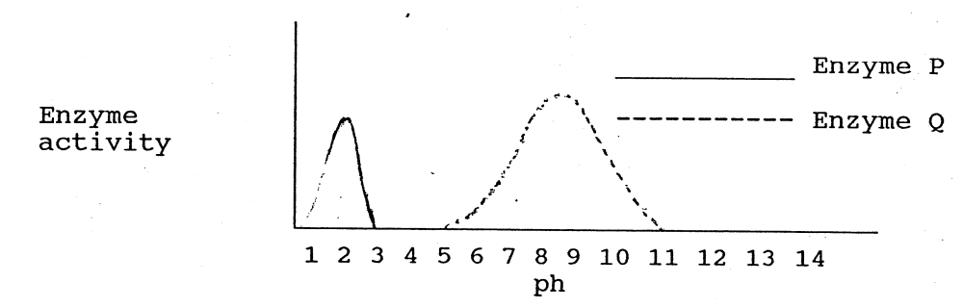

22. Enzyme P is most likely to be:

- Ptyalin
- Lipase
- Gastric protease
- it is impossible to say

23. Which of the following statements about P and Q is true?

- Enzyme P is most active in an acidic medium and enzyme Q is most active in an alkaline medium
- Enzyme Q will only be activated in one part of the digestive tract however enzyme P will be active all along the digestive tract
- Enzyme Q will only break down carbohydrate however enzyme P will break down carbohydrate, protein and lipids
- Enzyme P will be active over a wider pH range than enzyme Q

24. Bile is secreted into the duodenum. Its function in digestion is to:

  - chemically digest lipids.
  - neutralise the acids of the stomach.
  - emulsify fats.
  - complete the digestion of proteins.

25. The removal of metabolic wastes from the body is termed:

- respiration
- excretion
- elimination
- digestion

SECTION B – Written Answers

Write all answers in the spaces provided. Total = 60 Marks

- Terminology
Complete the table using the best scientific term that matches each statement.

Projections which cover the surface of the villus | Microvilli
The acid which is secreted into the gastric pits in the stomach | Hydrochloric acid
Type of wastes excreted by excretory system | Metabolic
Arteriole that enters the kidney | Afferent
A disease in which glucose frequently appears in the urine | Diabetes
Knot of capillaries where blood is filtered of all substances except red blood cells and large proteins | Glomerulus
Chemical process in which nutrients are broken down into small molecules so they can be absorbed by the body | Digestion
The organ which produces bile using the haemoglobin in worn out red blood cells | Liver
Proteins are long chains of smaller sub-units called | Amino acids
Small finger-like projections that line the small intestine | Villi
The contraction of muscles which moves food along the digestive tract | Peristalsis
Structure which stores urine | Bladder
Organ responsible for filtering blood | Kidney
Process performed in the liver which breaks down proteins | Deamination
Undigested food eliminated by the body | Faeces

(15 Marks)

- Label the diagram of the urinary system below.

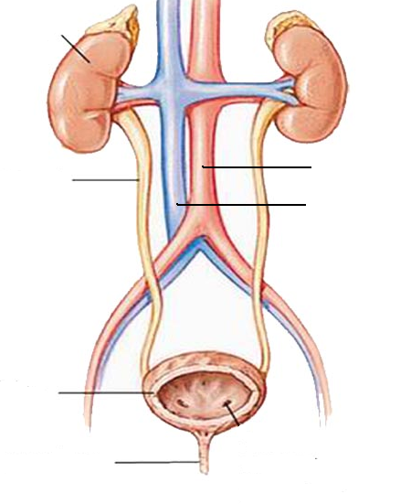

(3 Marks)

- Complete the table below:

Food Type  (substrate) | Where chemical digestion occurs | Enzyme  involved | Food Source  (one example) | End product  of chemical  digestion
protein | stomach  small intestine | Protease | Meat | Amino acids
carbohydrate | mouth  small intestine | amylase | Bread, pasta etc | glucose
fats/lipids | small intestine | lipase | butter | Fatty acids and glycerol

(6 Marks)

- Use the diagrams below to answer the following questions.

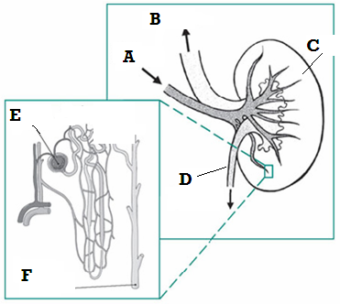

  - Structure A is the: ____Renal artery_________________________
  - Structure D is the: ____Ureter________________________________
  - Structure E is the: ______Glomeralus______________________________
  - Structure F is the: _____Collecting tubule____________________________
(2 Marks)

  - Name the structural unit which includes E and F ___Nephron______________
(1 Mark)

  - What is the function of this structure? ___To filter waste products from the blood___________________________________________________
(1 Mark)

  - List the main components that make up urine.
    - ____Water_______________
    - ____Urea_______________
    - ____chloride, sodium, potassium, creatinine,various ions/salts, _____ (3 Marks)
- The table below shows a comparison of the concentration of various substances in the plasma, the filtrate and urine. Use the following descriptions to complete the Filtrate and Urine columns of the table.

- None present
- Higher than plasma
- Lower than plasma
- Same as plasma

Substance | Plasma (g/100mL) | Filtrate (g/100mL) | Urine (g/100mL)
Amino acids | 0.05 | Higher | None
Glucose | 0.10 | Higher | None
Proteins | 8.00 | None/Less | None/Less
Salts | 0.72 | Higher | Higher
Urea | 0.02 | Higher | Higher

(5 Marks)
- How is mechanical digestion different to chemical digestion?
Mechanical digestion – uses mechanical measures (muscular contraction, chewing to simplify macromolecules
Chemical digestion – uses enzymes to simplify macromolecules
(2 Marks)
- Describe the mechanical digestion that takes place in:
  - The mouth the teeth masticate (chew) the food, breaking it up into small pieces before the mouth and tongue roll it into a ball-shaped bolus
  - The stomach churns the food through muscular contractions that further divides it into smaller pieces
  - The small intestine muscular contractions move the food backwards and forwards along the length (8m) of the tube mixing bile and enzymes and forming sebments in the food mass. Bile released by the gall bladder into the duodenum emulsifies the fats and oils.
(3 Marks)

What is the function of saliva?

Any two (1 mark each)

Lubricates food and mouth

Holds bolus together for swallowing

Contains salivary amylase for chemical digestion of carbohydrates
2 Marks)

7. What is absorbed by the large intestine? ___Water and vitamins_______________
(1 Mark)
- What are two factors that influence the efficiency of enzymes in digestive reactions?

- _____Temperature___________________________
- _____pH___________________________
(2 Marks)

9. Name the four basic activities of the digestive system:

- ingestion b) digestion

c) absorption d) elimination

(2 Marks)
10. Name the structure shown in the diagram below? ____Villus__________
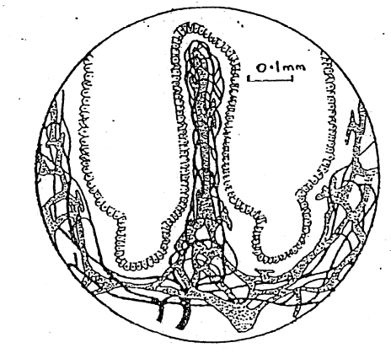
(1 Mark)

11. Describe the main function of this structure? __
Absorption of nutrients from digested food________________________
(1 Mark)

12. Describe two ways in which this structure is suited to its function.

Any two (1 mark each)
Finger like adding to surface area available for absorption
Has lacteal for fatty acid absorption and blood supply for amino acid and saccharide absorption
Have secretory cells for lubrication
Continual movement of villi brings these in contact with different parts of intestinal contents
(1 Mark)

- Explain the difference between the terms ‘excretion’ and ‘elimination’.
Excretion – removal of metabolic wastes from the body.
Elimination – removal of undigested food substances from the body.
(2 Marks)

- Why is concentrated urine more harmful than diluted urine?

Generally the more concentrated a substance is, the more harmful it is. The waste products are toxic to cells and diluting it with water reduces the effects.

(2 Marks)

- Complete the table to label the diagram below.
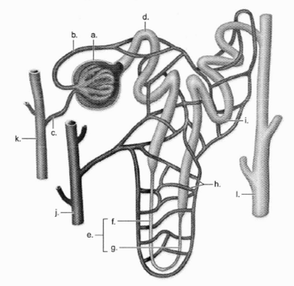
(5 Marks)
a | Glomerulus/capsule
b | Efferent arteriole
c | Afferent arteriole
d | Proximal convoluted tubule
f | Descending loop of Henle
g | Ascending loop of Henle
h | Capillaries
i | Distal convoluted tubule
j | Renal vein
k | Renal artery

SECTION C – Extended Answer (Total 10 Marks)

1. Describe how the excretory system regulates the chemical composition of body fluids. In your answer discuss the role of the kidneys, liver, lungs and skin.

KIDNEYS
- Blood enters kidney via renal artery, a branch of the aorta
- Nephrons filter the blood
- Filtrate is pushed into the glomerular capsule
- High pressure is created by the heart and arteries
- Pressure is increased by the narrow lumen of the glomerulus and efferent arteriole
- Substances in the filtrate that are still needed are reabsorbed in the tubules of the nephron.
- Glucose and amino acids are reabsorbed in the proximal convoluted tubule
- Water may be reabsorbed in proximal and distal convoluted tubule and in the loop of Henle.
- Excess minerals, urea and other metabolic wastes move to the collecting ducts and are excreted via the ureters, bladder and urethra.
- Some molecules are reabsorbed by diffusion, some by active transport.
- Hydrogen ions and other ions that may be in excess in the blood are actively secreted into the convoluted tubules.
- Nephrons are able to regulate pH of the blood.
- Long proteins and blood cells are too large to be filtered and remain in the blood.
- Filtered blood leaves the kidney via the renal vein.
LIVER
- Proteins and amino acids cannot be stored in the body.
- The liver deaminates excess amino acids and proteins.
- Deamination produces ammonia then urea and useful carbohydrates.
- Urea is toxic and must be removed from the blood.
- Formula would be good
LUNGS
- CO₂ produced by cells is a metabolic waste that needs to be excreted.
- The blood carries CO₂ to the lungs.
- In the lungs, CO₂ is exchanged for O₂
- CO₂ is exhaled.
SKIN
- Some urea and other metabolic wastes are lost with sweat from the skin.
- This is only a secondary function of sweat glands – their primary function is temperature control.
(Must have at least 2 points from each organ to get full marks)

